**Evaluation**

A screenshot of the confusion matrix can be seen below:

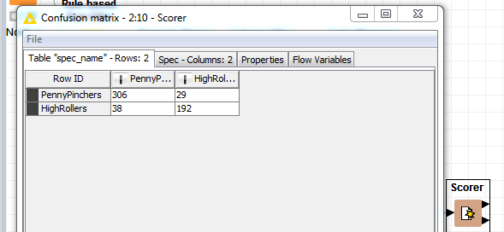

As seen in the screenshot above, the overall accuracy of the model is **0.8814159 (which is mentioned in flow variables in the above screenshot or we can calculate based on correct/total i.e. (306+192)/565)**

306: These are the penny pinchers which were correctly predicted i.e. true positive.

29: These are the high rollers which were predicted as penny pinchers i.e. false positive.

38: These are the penny pinchers which were predicted as high rollers i.ie false positive.

192: These are the high rollers which were predicted correctly i.e. true positive.